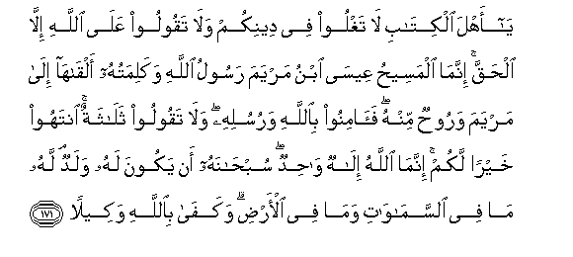

'O people of the Book! Exceed not in your religion, and do not say of Allah any thing but truth. The Messiah JESUS son of MARY is only the Messenger of Allah and His word that was sent to Mary and a spirit from Him. Then believe in Allah and His Messengers and do not say, 'three'. Refrain for your own good. Allah is the only one God. Far is it from His Holiness that He should have a son. To Him belongs whatever is in the heavens and whatever is in the earth. And Allah is Sufficient, as real Doer.
QUR’AN 4:171
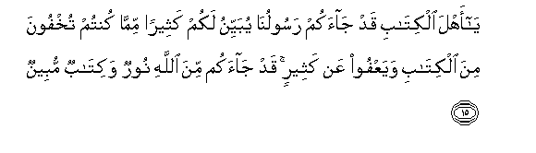

'O people of the Book! Undoubtedly, Our Messenger has come to you who makes clear to you much of that which you had hidden in the Book and pardons much. Undoubtedly, there has come to you from Allah a light and a Book, luminous
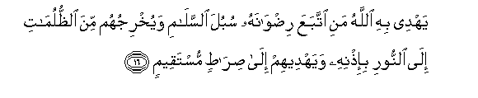 Allah guides therewith him who followed His pleasure into the ways of peace and carries them to light from the darkness by His Command and shows them right path.
QUR’AN 5: 15 & 16

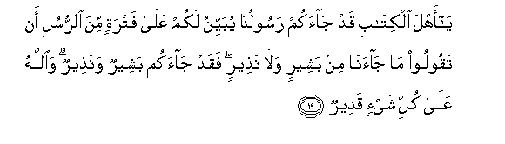 'O people of the Book! Undoubtedly, there has come to you Our this Messenger who makes clear to you Our Commands, after a break of the coming of messenger for a long time lest you say' 'there came not to us any bearer of glad tidings or Warner, then now there has come to you a bearer of glad tidings and Warner. And Allah is Potent over everything
QUR’AN 5:19

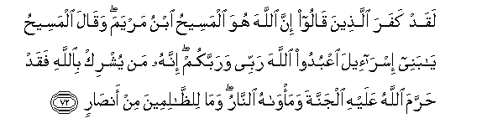
Undoubtedly, those are infidels, who say, "Messiah son of Mary is the very Allah'. And whereas Messiah had said 'O children of ISRAEL worship Allah, my Lord and your Lord Undoubtedly, whoso. Associates anyone with Allah, then Allah has forbidden paradise to him and his abode is Hell. And there is no helper of unjust.
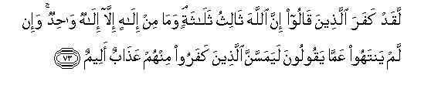

Undoubtedly, those are infidels who say, 'Allah is third of the three Gods, and there is no God but the one God. And if they desist not from what they say, then a painful torment shall surely befall to those who will die as infidels.
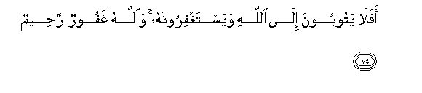 Then why they do not turn towards Allah and ask His Forgiveness? And Allah is Forgiving, Merciful
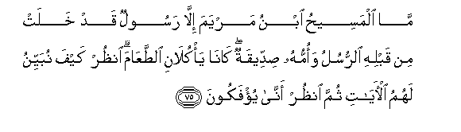 The Messiah son of Mary was not but a Messenger, many Messengers passed away before him. And his mother is a truthful woman. Both used to take food. See how clear signs We explain for them, then see how they are turned away
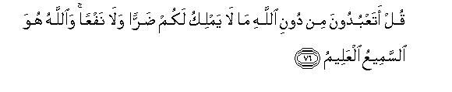 Say you, 'Do you worship beside Allah, that which is neither master of your loss nor of profit. And Allah is the Hearing, the knowing.
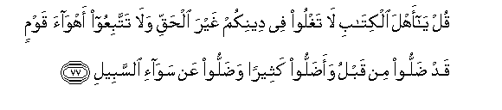
'O people of the Book! Exceed not the limits in your religion unjustly, and follow not the desires of a people who have already gone astray and caused many to go astray and have strayed away from the right path.
QUR’AN 5:72 to 77
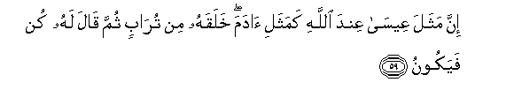
The likeness of JESUS with Allah, is like Adam. He created him of dust, then said, 'Be and 'he' was atonce
QUR’AN 3:59

'O people of the Book! Why do you deny the signs of Allah, whereas you are yourselves witnesses.
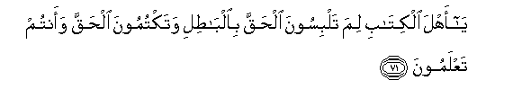'O people of the Book! Why do you confound truth with falsehood and why do you conceal the truth whereas you have knowledge?
QUR’AN 3:70 & 71

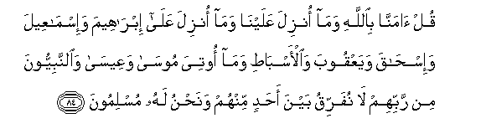Say like this, 'that We believed in Allah and in that which was sent down to us and in that which Was sent down to ABRAHAM and ISHMAEL and ISHAQ and JACOB and his children and that which was given to MOSES and JESUS and prophets from their Lord. We make no distinction between any of them in believing and to Him we have bowed down our necks.
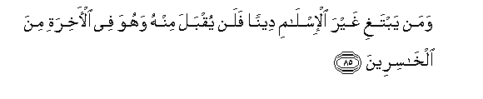And whoso will desire for a religion other than Islam that shall never be accepted from him and in the next world he shall be among the losers.
QUR’AN 3:84 &85

