Quotes from the The American Taliban
Ann Coulter
 | "We should invade their countries, kill their leaders and convert them to Christianity. We weren't punctilious about locating and punishing only Hitler and his top officers. We carpet-bombed German cities; we killed civilians. That's war. And this is war."  "Not all Muslims may be terrorists, but all terrorists are Muslims."  "Being nice to people is, in fact, one of the incidental tenets of Christianity, as opposed to other religions whose tenets are more along the lines of 'kill everyone who doesn't smell bad and doesn't answer to the name Mohammed'"

Bailey Smith
"With all due respect to those dear people, my friend, God Almighty does not hear the prayer of a Jew." | 

Beverly LaHaye (Concerned Women for America)
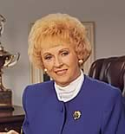 | "Yes, religion and politics do mix. America is a nation based on biblical principles. Christian values dominate our government. The test of those values is the Bible. Politicians who do not use the bible to guide their public and private lives do not belong in office."

Bob Dornan (Rep. R-CA)
"Don't use the word 'gay' unless it's an acronym for 'Got Aids Yet'" | 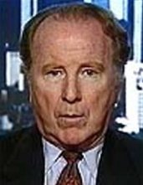

David Barton (Wallbuilders)
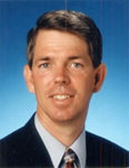 | "There should be absolutely no 'Separation of Church and State' in America."

David Trosch
"Sodomy is a graver sin than murder. – Unless there is life there can be no murder." | 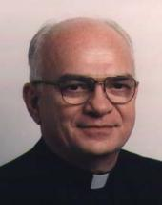

Fob James (Governor of Alabama)
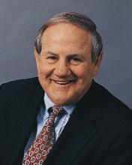 | "Behind this judicial wall of separation there is a tyranny of lies that will fall... I say to you, my friends, let it fall!"  "A good butt-whipping and then a prayer is a wonderful remedy."

Fred Phelps (Westboro Baptist Church)
"If you got to castrate your miserable self with a piece of rusty barb wire, do it."  "Hear the word of the LORD, America, fag-enablers are worse than the fags themselves, and will be punished in the everlasting lake of fire!"  "You telling these miserable, Hell-bound, bath house-wallowing, anal-copulating fags that God loves them!? You have bats in the belfry!"  "American Veterans are to blame for the fag takeover of this nation. They have the power in their political lobby to influence the zeitgeist, get the fags out of the military, and back in the closet where they belong!"  "Not only is homosexuality a sin, but anyone who supports fags is just as guilty as they are. You are both worthy of death." | 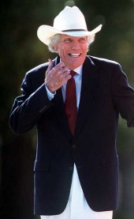

Gary Bauer (American Values)
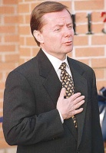 | "We are engaged in a social, political, and cultural war. There's a lot of talk in America about pluralism. But the bottom line is somebody's values will prevail. And the winner gets the right to teach our children what to believe."

Gary North (Institute for Christian Economics)
"The long-term goal of Christians in politics should be to gain exclusive control over the franchise. Those who refuse to submit publicly to the eternal sanctions of God by submitting to His Church's public marks of the covenant–baptism and holy communion–must be denied citizenship."  "This is God's world, not Satan's. Christians are the lawful heirs, not non-Christians." | 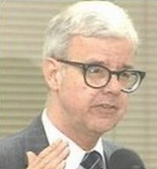

Gary Potter (Catholics for Christian Political Action)
 | "When the Christian majority takes over this country, there will be no satanic churches, no more free distribution of pornography, no more talk of rights for homosexuals. After the Christian majority takes control, pluralism will be seen as immoral and evil and the state will not permit anybody the right to practice evil."

George Bush Sr. (President of the United States)
"I don't know that atheists should be considered citizens, nor should they be considered patriots. This is one nation under God." | 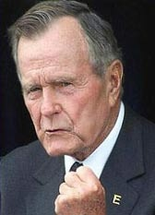

George W. Bush (President of the United States)
 | "I don't think that witchcraft is a religion. I wish the military would rethink this decision."*  "God told me to strike at al Qaida and I struck them, and then he instructed me to strike at Saddam, which I did, and now I am determined to solve the problem in the Middle East. If you help me I will act, and if not, the elections will come and I will have to focus on them."  "Either you are with us, or you are with the terrorists."  "This crusade, this war on terrorism is going to take a while."
 | *Comment about Wiccans in the military

Henry Morris (Institute for Creation Research)
"When science and the Bible differ, science has obviously misinterpreted its data." | 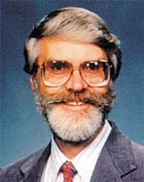

J. B. Stoner (White Supremacist)
 | "We had lost the fight for the preservation of the white race until God himself intervened in earthly affairs with AIDS to rescue and preserve the white race that he had created.... I praise God all the time for AIDS."  "AIDS is a racial disease of Jews and Niggers, and fortunately it is wiping out the queers. I guess God hates queers for several reasons. There is one big reason to be against queers and that is because every time some white boy is seduced by a queer into becoming a queer, means his white bloodline has run out."

James Dobson (Focus on the Family)
"Those who control the access to the minds of children will set the agenda for the future of the nation and the future of the western world."  "State Universities are breeding grounds, quite literally, for sexually transmitted diseases (including HIV), homosexual behavior, unwanted pregnancies, abortions, alcoholism, and drug abuse."  "Today's children... They're damned. They're gone." | 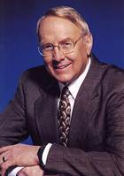

James Kennedy (Center for Reclaiming America)
 | "The Christian community has a golden opportunity to train an army of dedicated teachers who can invade the public school classrooms and use them to influence the nation for Christ."

James Watt (Secretary of the Interior)
"We don't have to protect the environment, the Second Coming is at hand."* | 
*Secretary of the Interior in the Reagan Admin. Responsible for National Policy regarding the Environment

Jay Grimstead (Coalition on Revival)
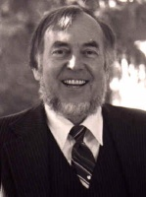 | "We are to make Bible-obeying disciples of anybody that gets in our way."

Jerry Falwell
"We're fighting against humanism, we're fighting against liberalism...we are fighting against all the systems of Satan that are destroying our nation today...our battle is with Satan himself."  "AIDS is the wrath of a just God against homosexuals. To oppose it would be like an Israelite jumping in the Red Sea to save one of Pharoah's chariotters."  "The Bible is the inerrant ... word of the living God. It is absolutely infallible, without error in all matters pertaining to faith and practice, as well as in areas such as geography, science, history, etc."  "AIDS is not just God's punishment for homosexuals; it is God's punishment for the society that tolerates homosexuals."  "If you're not a born-again Christian, you're a failure as a human being." | 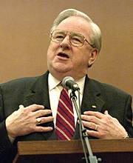

Jesse Helms (Sen. R-NC)
 | "The New York Times and Washington Post are both infested with homosexuals themselves. Just about every person down there is a homosexual or lesbian."  "All Latins are volatile people. Hence, I was not surprised at the volatile reaction."  "Your tax dollars are being used to pay for grade-school classes that teach our children that cannibalism, wife-swapping and murder of infants and the elderly are acceptable behavior."  "Homosexuals are weak, morally sick wretches."

Jimmy Swaggart (Jimmy Swaggart Ministries)
"The Media is ruled by Satan. But yet I wonder if many Christians fully understand that. Also, will they believe what the Media says, considering that its aim is to steal, kill, and destroy?"  "Sex education classes in our public schools are promoting incest."  "Evolution is a bankrupt speculative philosophy, not a scientific fact. Only a spiritually bankrupt society could ever believe it...Only atheists could accept this Satanic theory." | 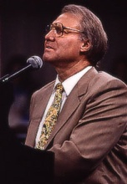

John Ashcroft (Attorney General)
 | "Civilized people – Muslims, Christians, and Jews – all understand that the source of freedom and human dignity is the Creator."

John Whitehead (Rutherford Institute)
"The [Supreme] Court, by seeking to equate Christianity with other religions, merely assaults the one faith. The Court in essence is assailing the true God by democratizing the Christian religion." | 

Joseph McCarthy (Sen. R-WI)
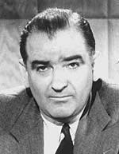 | "Today we are engaged in a final, all-out battle between Communistic Atheism and Christianity."

Joseph Morecraft (Chalcedon Presbyterian Church)
"Nobody has the right to worship on this planet any other God than Jehovah. And therefore the state does not have the responsibility to defend anybody's pseudo-right to worship an idol." | 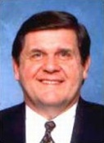

Joseph Scheidler (Pro-Life Action League)
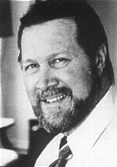 | "I would like to outlaw contraception...contraception is disgusting – people using each other for pleasure."*
 | *I get the distinct impression that Mr. Scheidler's poor wife isn't guilty of feeling any pleasure…

Kay O'Connor (Kansas Senate Republican)
"I'm an old-fashioned woman. Men should take care of women, and if men were taking care of women today, we wouldn't have to vote." | 

Keith A. Fournier (Catholic Way)
 | "We need a legal strategy which protects the rights of those of us who hold Christian convictions which will afford us the opportunity to contend once again for the mind of this culture."

Laura Schlessinger
"I want to coin a phrase here, and I don't mind help. What would be the communication version of "ethnic cleansing?" Because that's what in particular the homosexual activists try to do." | 

Lester Roloff (Texas Homes for Wayward Youth)
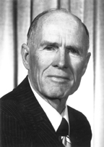 | "Better a pink bottom than a black soul."*
 | *Roloff opened a chain of homes for "wayward" youth in the state of Texas; he was later jailed in 1973 and again in 1975 for child abuse due to the punitive punishment techniques used in his homes. He would have been finished had he not of been specifically given permision to re-open his homes by, you guested it, Governor George W Bush.

Lt. Gen. William G. Boykin
“George Bush was not elected by a majority of the voters in the United States, he was appointed by God.” | 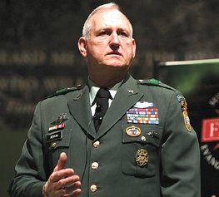

Pat Buchanan (Presidential Candidate)
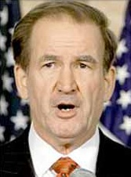 | "Our culture is superior. Our culture is superior because our religion is Christianity and that is the truth that makes men free."  "There were no politics to polarize us then, to magnify every slight. The "negroes" of Washington had their public schools, restaurants, bars, movie houses, playgrounds and churches; and we had ours."  "Rail as they will about 'discrimination,' women are simply not endowed by nature with the same measures of single-minded ambition and the will to succeed in the fiercely competitive world of Western capitalism."

Pat Robertson (Christian Coalition)
"The Islamic people, the Arabs, were the ones who captured Africans, put them in slavery, and sent them to America as slaves. Why would the people in America want to embrace the religion of slavers."  "Just like what Nazi Germany did to the Jews, so liberal America is now doing to the evangelical Christians. It's no different...More terrible than anything suffered by any minority in history."  "When lawlessness is abroad in the land, the same thing will happen here that happened in Nazi Germany. Many of those people involved with Adolph Hitler were Satanists, many of them were homosexuals – the two things seem to go together."  "The feminist agenda is not about equal rights for women. It is about a socialist, anti-family political movement that encourages women to leave their husbands, kill their children, practice witchcraft, destroy capitalism, and become lesbians."  "You say you're supposed to be nice to the Episcopalians and the Presbyterians and the Methodists and this, that, and the other thing. Nonsense, I don't have to be nice to the spirit of the Antichrist."  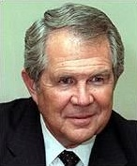  "I know this is painful for the ladies to hear, but if you get married, you have accepted the headship of a man, your husband. Christ is the head of the household and the husband is the head of the wife, and that's the way it is, period."  "[Homosexuals] want to come into churches and disrupt church services and throw blood all around and try to give people AIDS and spit in the face of ministers."  "[Planned Parenthood] is teaching kids to fornicate, teaching people to have adultery, every kind of bestiality, homosexuality, lesbianism – everything that the Bible condemns." | 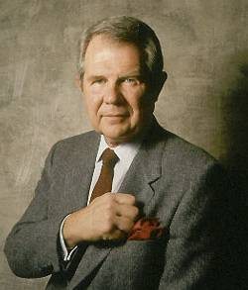

Patrick Mahoney (Christian Defense Coalition)
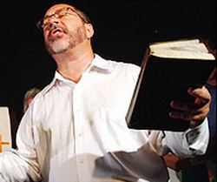 | "It is deeply troubling to have an appointed, unelected commission remove an elected official from office [Roy Moore]. The Court of Judiciary has overturned an election and crushed the democratic process through their actions."*
 | *Interesting perspective coming from someone who's President was appointed by a group of "unelected judges", thus overturning a democratic election.

Paul Cameron
"I think that actually AIDS is a guardian. That is I think it was sent, if you would, about forty years ago, to destroy Western civilization unless we change our sexual ways. So it's really a Godsend."  "Homosexuality is a crime against humanity."  "Causes of homosexuality include: 'sex with animals'"*  "Unless we get medically lucky, in three or four years, one of the options discussed will be the extermination of homosexuals." | 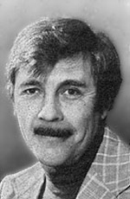
*Paul Cameron was discharged from the American Psychological Association, the Nebraska Psychological Association, and the American Sociological Association due to his unethical practices and biased research regarding Homosexuals. His "research" has since been discredited by the scientific community; however his work is still referenced by many fundamentalist organizations as credible.

Randall Terry (Operation Rescue)
 | "I want you to just let a wave of intolerance wash over. I want you to let a wave of hatred wash over you. Yes, hate is good...Our goal is a Christian nation. We have a biblical duty, we are called by God to conquer this country. We don't want equal time. We don't want pluralism."  "Our goal must be simple. We must have a Christian nation built on God's law, on the ten Commandments. No apologies."  "I don't think Christians should use birth control. You consummate your marriage as often as you like – and if you have babies, you have babies."  "When I, or people like me, are running the country, you'd better flee, because we will find you, we will try you, and we'll execute you. I mean every word of it. I will make it part of my mission to see to it that they are tried and executed."*  "There is going to be war, [and Christians may be called to] take up the sword to overthrow the tyrannical regime that oppresses them."
 | *It is interesting to note that Randell Terry's son is Gay

Jerry Vines (Southern Baptist Convention)
"They would have us believe that Islam is just as good as Christianity. Christianity was founded by the virgin-born son of God, Jesus Christ. Islam was founded by Muhammad, a demon-possessed pedophile who had 12 wives, the last one of which was a nine-year-old girl." | 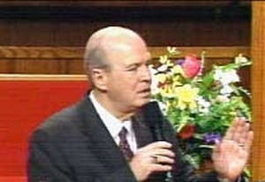

Rick Santorum* (Sen. R-PA)
 | "If the Supreme Court says that you have the right to consensual [Gay] sex within your home, then you have the right to bigamy, you have the right to polygamy, you have the right to incest, you have the right to adultery. You have the right to anything!"
 | *Now known as Rick "Santorum" Santorum

Robert Simonds (Citizens for Excellence in Education)
"As the church watches from the sidelines, the ungodly elect atheists and homosexuals to school boards and legislatures to enact policies and laws that destroy our Christian children and discriminate against Christian families."  "Atheistic secular humanists should be removed from office and Christians should be elected...Government and true Christianity are inseparable."  "We'll take away their power and their money. Money comes from students. We'll break their backs by taking 24 million kids out of the public schools." | 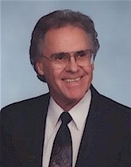

Robert T. Lee (Society for the Practical Establishment of the Ten Commandments)
 | "Raising your children under Americanism or any other principles other than true Christianity is child abuse."  "You do not have the right to be wrong, regardless of what any man-made or demonic charter says."  "Democracy originated in the mind of a rational being who has the deepest hatred for God."  "Do you realize that the only thing that gives democracy existence is sin? The absence of democracy is perfect obedience to god."  "The best way to insure the earth is never over populated is for sensible and righteous governments to clear all forms of atheism and heresy."

Ronald Reagan (President of the United States)
"For the first time ever, everything is in place for the Battle of Armageddon and the Second Coming of Christ." | 

Roy Moore (Former Alabama Judge)
 | "If they want to get the Commandments, they're going to have to get me first."*  "Worship With Your Vote"
 | *Interesting observation of the Radical Right, Judge Roy Moore commits peaceful civil disobedience by refusing to remove the Ten Commandments Monument from the Court. He is considered a Hero. Mayor Gavin Newsom commits peaceful civil disobedience by issuing same-sex marriage licenses. He is considered an Anarchist.

Rush Limbaugh
"Feminism was established to allow unattractive women easier access to the mainstream of society."  "If you commit a crime, you're guilty."*  "There is only one way to get rid of nuclear weapons... use them" | 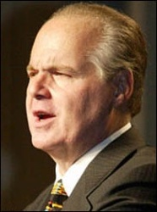
*Seems logical enough, doesn't it Rush?

Star Parker (Coalition on Urban Renewal & Education)
 | "Anybody that believes in separation of church and state needs to leave right now."

Tony Evans (Promise Keepers)
"The demise of our community and culture is the fault of sissified men who have been overly influenced by women." | 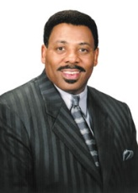

William Rehnquist (Chief Justice of the U.S. Supreme Court)
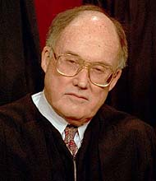 | "The 'wall of separation between church and state' is a metaphor based on bad history, a metaphor which has proved useless as a guide to judging. It should be frankly and explicitly abandoned."

Michael Savage (Savage Nation)
"Oh, you're one of the sodomites. You should only get AIDS and die, you pig. How's that? Why don't you see if you can sue me, you pig. You got nothing better than to put me down, you piece of garbage. You have got nothing to do today, go eat a sausage and choke on it."* | 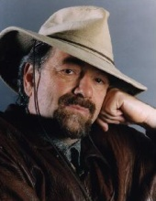
*Statement made on live national television

