Types of bridges
there are six main types of bridges: beam bridges, cantilever bridges, arch bridges, suspension bridges, cable-stayed bridges and truss bridges.

By use
A bridge is designed for trains, pedestrian or road traffic, a pipeline or waterway for water transport or barge traffic. An aqueduct is a bridge that carries water, resembling a viaduct, which is a bridge that connects points of equal height. A Road-rail bridge carries both road and rail traffic.
A beam bridge is a direct descendant of the log bridge, now more normally made from shallow steel 'I' beams, box girders, reinforced concrete, or post-tensioned concrete. It is frequently used in pedestrian bridges and for highway overpasses and flyovers. As is its ancestor, this bridge is in structural terms the simplest of the many bridge types.
Like most bridges that are characterized by how they are supported, beam bridges consist of one horizontal beam with 2 supports usually on either end.
Decorative beam bridges, commonly built from cedar, pine, and redwood, can span a koi pond or country creek. These free standing bridges are usually built as functional walkways or just for decoration.
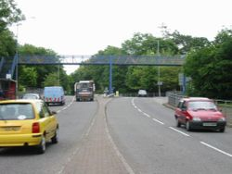

A steel pedestrian footbridge over a busy road in Swansea, typical of many beam bridges (the superstructure supports only the fence, not the bridge).

A cantilever bridge is a bridge built using cantilevers: structures that project horizontally into space, supported on only one end. For small footbridges, the cantilevers may be simple beams; however, large cantilever bridges designed to handle road or rail traffic use trusses built from structural steel, or box girders built from prestressed concrete. The steel truss cantilever bridge was a major engineering breakthrough when first put into practice, as it can span distances of over 1,500 feet (460 m), and can be more easily constructed at difficult crossings by virtue of using little or no falsework.

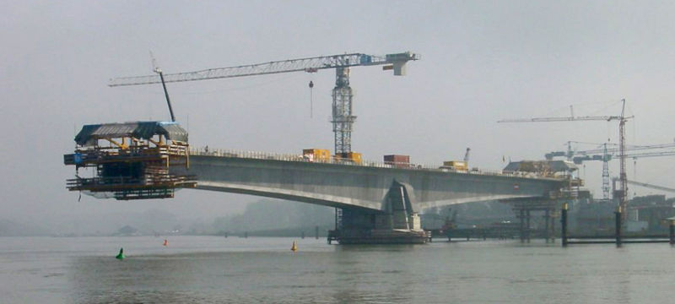

An arch bridge is a bridge with abutments at each end shaped as a curved arch. Arch bridges work by transferring the weight of the bridge and its loads partially into a horizontal thrust restrained by the abutments at either side. A viaduct (a long bridge) may be made from a series of arches, although other more economical structures are typically used today.

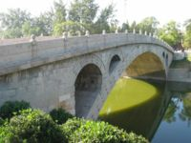

The 1,400 year old Zhaozhou Bridge of China

A suspension bridge is a type of bridge where the main load-bearing elements are hung from suspension cables. While modern suspension bridges with level decks date from the early 19th century, earlier types are reported from the 3rd century BC. Simple suspension bridges, for use by pedestrians and livestock, are still constructed, based upon the ancient Inca rope bridge.

Suspended well from two high locations over a river or canyon, simple suspension bridges follow a shallow downward arc and are not suited for modern roads and railroads. Advances in materials and design led to the development of the suspended-deck suspension bridge, a modern bridge capable of carrying vehicles and light rail. Instead of the deck following the downward arc of the main load-bearing cables (or chains), these cables are suspended between towers.

The suspension cables must be anchored at each end of the bridge, since any load applied to the bridge is transformed into a tension in these main cables. The main cables continue beyond the pillars to deck-level supports, and further continue to connections with anchors in the ground (An exception is the Royal Albert Bridge (1859) where the anchors are replaced by an arch between the columns.) The roadway is supported by vertical suspender cables or rods, called hangers. In some circumstances the towers may sit on a bluff or canyon edge where the road may proceed directly to the main span, otherwise the bridge will usually have two smaller spans, running between either pair of pillars and the highway, which may be supported by suspender cables or may use a truss bridge to make this connection. In the latter case there will be very little arc in the outboard main cable

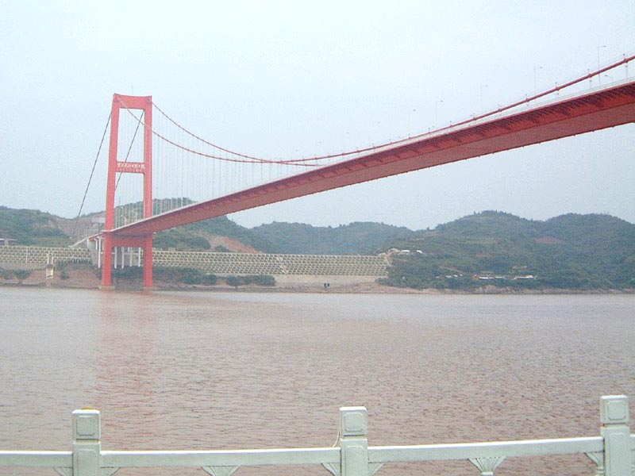

A plate deck suspension bridge over the Yangtze River in China

A cable-stayed bridge is a bridge that consists of one or more columns (normally referred to as towers or pylons), with cables supporting the bridge deck. There are two major classes of cable-stayed bridges, differentiated by how the cables are connected to the tower(s). In a harp design, the cables are made nearly parallel by attaching cables to various points on the tower so that the height of attachment of each on the tower is similar to the distance from the tower along the roadway to its lower attachment. In a fan design, the cables all connect to or pass over the top of the tower. The cable-stay design is the optimum bridge for a span length between that of cantilever bridges and suspension bridges. Within this range of span lengths a suspension bridge would require a great deal more cable, while a full cantilever bridge would require considerably more material and be substantially heavier. However, such assertions are not absolute for all cases

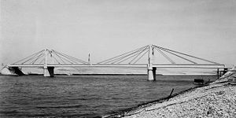

First modern concrete cable-stayed bridge, Donzère Mondragon (France), 1952

A truss bridge is a bridge composed of connected elements (typically straight) which may be stressed from tension, compression, or sometimes both in response to dynamic loads. Truss bridges are one of the oldest types of modern bridges. This type of bridge structure has a fairly simple design and is particularly cheap to construct owing to its efficient use of materials. For purposes of analysis most truss bridges may be considered to be pin jointed where the straight components meet. A more complex analysis may be required where rigid joints impose significant bending loads upon the elements.
